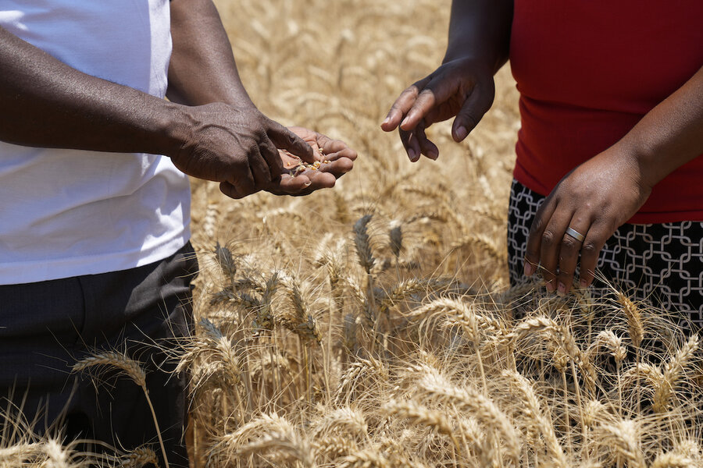

**Building a better Zimbabwe for generations to come through Agriculture**

Get in touch with the Master Farmer for more info.

Name: Plaxades S. Mukhalela

Tell: +27605533553

Email: plaxadesmk@gmail.com

**Coping Strategies to Food Insecurity**

* **Spending households’ savings**
* **Unusual short-term migration**
* **Sale of livestock**
* **Borrowing money**
* **Casual jobs**
* Implementation of a Five-Year fertilizer Import substitution road map
* Pfumvudza/Intwasa conservation farming program
* Support for the domestic fertilizer value chain
* Ensuring rural transformation
* Petrol blending from E5 to E10
* Access to irrigation infrastructure
* The wheat input support program
* Suspension of import duties
* Water harvesting
* Transition from Relief to Recovery

Potential solutions to a Food Secure Zimbabwe

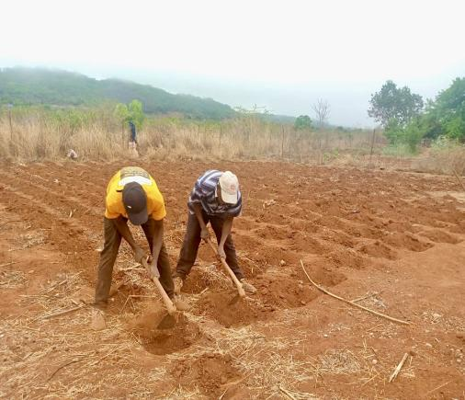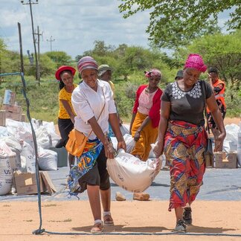

* Global Environmental Change (Prolonged Droughts)
* Continued decreased access to fuel and price increase
* Food inaccessibility and price increase of basic food basket
* Political instability
* Economic and Infrastructural collapse
* Agricultural inputs price hike and inaccessibility
* Hyperinflation and currency crisis
* A rise in the cost of living
* Flight and freight disruptions caused by Russia-Ukraine War
* Urbanization
* Water Access/Distribution
* HIV/AIDS and Covid-19
* Trade restrictions (US-China Trade war)

**Food Insecurity Drivers in Zimbabwe**

